
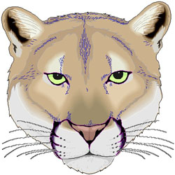
Mrs. Walton’s
Library News
Cornelius Science and Math Academy
Houston, TX

Volume 9, Issue 1
August

Public Libraries in the Cornelius Area
Park Place Library Mancuso Public Library
8145 Park Place 6767 Bellfort
Houston, TX 77017 Houston, TX 77087
832-393-1970 832-393-1920

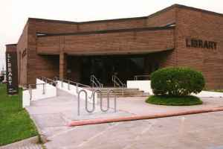
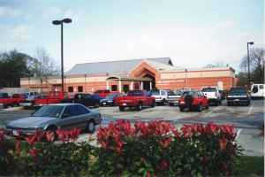

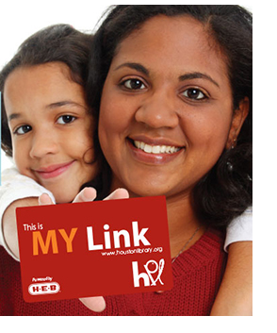

Welcome Back!!!!
Hello students and parents!!! I’m happy to see all of you back here for another school year. I want to send out a special welcome to all of you who are new to Cornelius. I look forward to sharing lots of new books, information, and activities with you this year. I am here to help make your year as successful as possible!!!

Do you have a library card? If you don’t, you should!! It’s so easy! You can sign up at any library or online. Having a library card allows you to check out LOTS OF books, movies, and e-books for your kindle, iPad, or tablet from any public library around the city and use the online resources of the Houston Public Library. That’s important since many school libraries are limited in the books and resources you may need. Visit one of the nearby libraries listed above to help get you and your children linked!

